Polymerisation

General formula for polymerisation of an alkene:
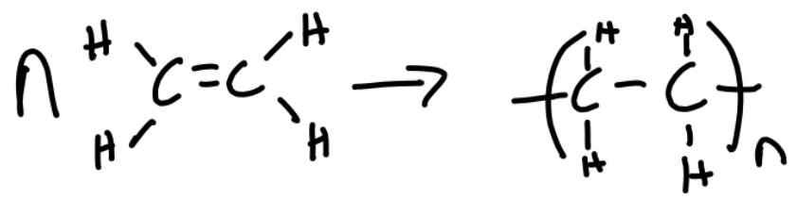

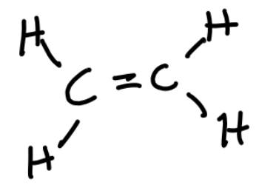
Polymers are very large molecules, formed from many repeating monomers.

Monomers are small molecules that combine to form a polymer.

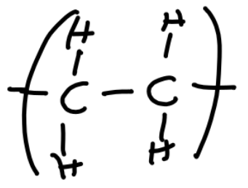
The repeating unit is the arrangement of atoms in the polymer that repeats.

Generally, in addition polymerisation the temperature is high, as well as the pressure, and there is a catalyst.

